### Profile

28 years old, Fourth-year Industrial Engineering student specializing in information systems,   
seeking a starting position to leverage my career.

Highly motivated, ambitious, and ready to learn.

### Contact

PHONE:

+97250-337-3320

EMAIL:

[benshuan@gmail.com](mailto:benshuan@gmail.com)

LINKEDIN:

[Ben Shuan](http://www.linkedin.com/in/)

GITHUB:

[Ben Shuan - Github](https://github.com/BenShuan)

### Hobbies

Surfing

Skating

Cooking – with the will to showoff

Running

### Languages

Hebrew - native language

English – advanced

## 

## EDUCATION

#### Kfar Silver – High School

September 2007 – June 2013

Graduated with 5 units in Math, English, Biology, and chemistry.

#### Ruppin Academic Center – B.Sc. Industrial Engineering

October 2020 - Current

**GPA: 90.88**

**Dean’s list for 2nd year**

Below are a few courses I have taken:

## Skills

* **Excel**
* Database Management and Design with **SQLserver**
* Information systems analysis and design
* Business intelligence with **QlikSense**
* Developing Internet Systems (**JS, HTML,CSS**)
* Introduction to big data

## WORK EXPERIENCE

#### Galim Surf School - Surf instructor

September 2019 – September 2022

I worked as a surf instructor with groups and individuals.

I have also worked as a surf instructor in Panama for four months, which made me utilize my English.

## Military service - IDF

#### Service – Sayeret Golani

March 2013 – November 2018

Full service as Sayeret Golani warrior and have done the officer course.

#### Combat officer

* Platoon leader for 16 months.
* Deputy Company Commander for 8 months

I finished my service as a Lieutenant, and now I serve as a Captain in the reserves as a Platoon leader.

Abilities I have acquired:

* working under pressure
* Public speaking
* Teamwork and individual work

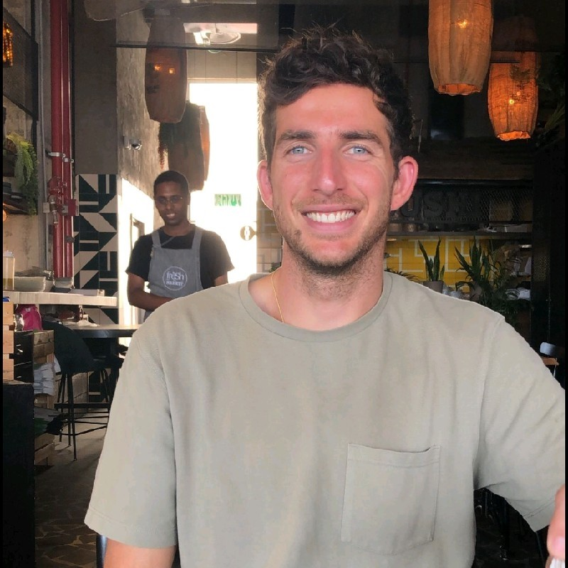

|  |
| --- |
|  |

Ben shuan

Industrial Engineer and management – information systems